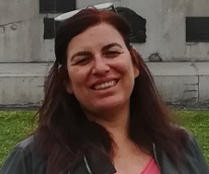
Anabela Rebelo
PhD in Chemistry and MSc in Industrial Chemistry

Senior officer at the Portuguese Environment Agency in the water resources department, where recently participate in the development of the new Portuguese Regulation on water reuse. Main duties include research, study and development of methodologies and scientific and technical processes in water resources management, with emphasis on water quality, wastewater discharges and water reuse, dangerous and hazardous substances to water and environmental risk assessment.
Delegate at the ISO Technical Committee 282 for water reuse and Portuguese focal point in the CIS Ad-hoc Task Group on Water Reuse at the European Commission. One of the two coordinators of the IMPEL Project “Integrated water Approach & Urban Reuse”, from IMPEL (European Union Network for the Implementation and Enforcement of Environmental Law).
Several publications in scientific journals and conference proceedings related with water resources management, including water reuse. Participation as invited speaker in several high-level conferences and workshops on Circular Economy and water reuse promoted by the European Commission.

